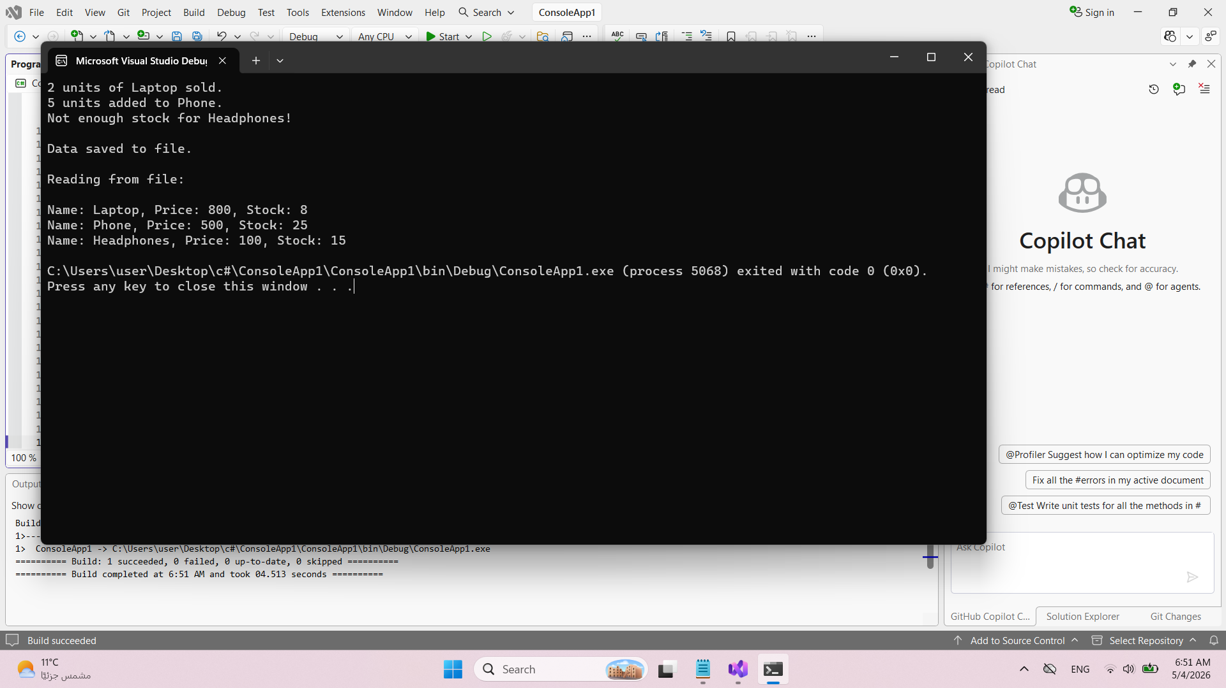
using System;
using System.IO;
using System.Collections.Generic;

class Product
{
// Private fields (Encapsulation)
private string name;
private double price;
private int stock;

// Properties with validation
public string Name
{
get { return name; }
set { name = value; }
}

public double Price
{
get { return price; }
set
{
if (value >= 0)
price = value;
else
Console.WriteLine("Price cannot be negative!");
}
}

public int Stock
{
get { return stock; }
set
{
if (value >= 0)
stock = value;
else
Console.WriteLine("Stock cannot be negative!");
}
}

// Constructor
public Product(string name, double price, int stock)
{
Name = name;
Price = price;
Stock = stock;
}

// Sell method
public void Sell(int quantity)
{
if (quantity <= stock)
{
stock -= quantity;
Console.WriteLine($"{quantity} units of {name} sold.");
}
else
{
Console.WriteLine($"Not enough stock for {name}!");
}
}

// Restock method
public void Restock(int quantity)
{
if (quantity > 0)
{
stock += quantity;
Console.WriteLine($"{quantity} units added to {name}.");
}
}

// Display method
public string GetDetails()
{
return $"Name: {name}, Price: {price}, Stock: {stock}";
}
}

class Program
{
static void Main()
{
// Create products
Product p1 = new Product("Laptop", 800, 10);
Product p2 = new Product("Phone", 500, 20);
Product p3 = new Product("Headphones", 100, 15);

// Perform operations
p1.Sell(2);
p2.Restock(5);
p3.Sell(20); // will show error

// Store products in a list
List<Product> products = new List<Product> { p1, p2, p3 };

string filePath = "products.txt";

// Write to file
List<string> lines = new List<string>();

foreach (var product in products)
{
lines.Add(product.GetDetails());
}

File.WriteAllLines(filePath, lines);

Console.WriteLine("\nData saved to file.\n");

// Read from file
string[] fileContent = File.ReadAllLines(filePath);

Console.WriteLine("Reading from file:\n");

foreach (string line in fileContent)
{
Console.WriteLine(line);
}
}
}

